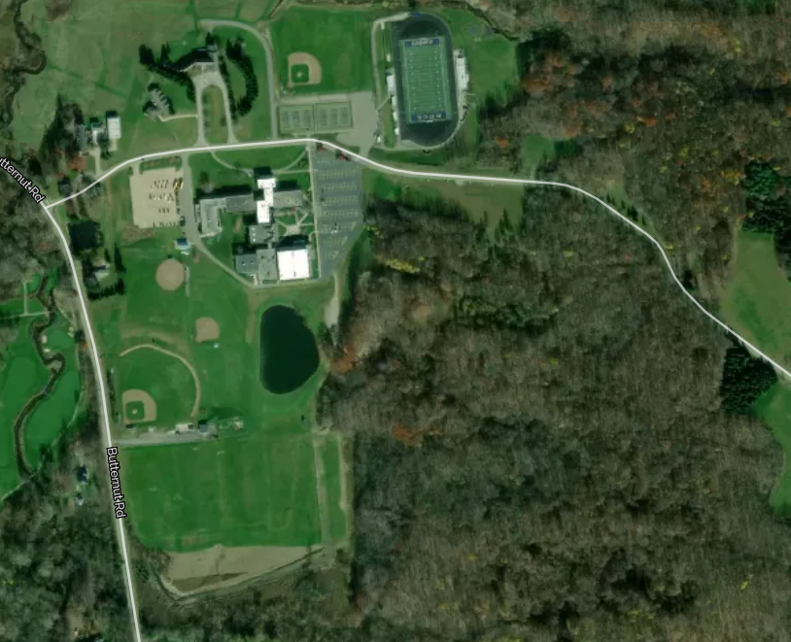
Team Camps
1 mi
Start
Finish
Notre Dame-Cathedral Latin (ND-CL) - CYO 1.5-mile XC Course Map – 2022
(Course path and marks are approximate on this map)

