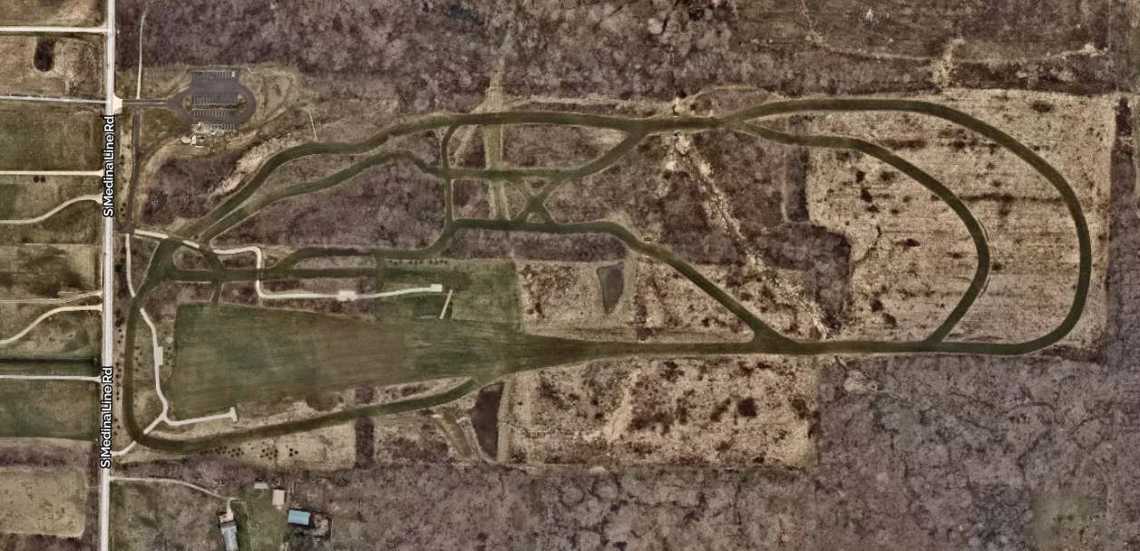
1 mile
Team
Camps
Start
Finish

Silver Creek - Cross Country Park – CYO 1.5-mile XC Course – 2022
(Course path and marks are approximate on this map)

